Process Analysis

Version | Author | Notes
V1.0 | Gia Hung Nguyen | Initial draft created

Contents
Introduction 2
Current State Overview 2
Current State Process Steps 2
Current State Issues 3
Future State Overview 4
Future State Process Steps 4
Future State Improvements 5
Summary of Key Changes 5

Introduction
This document presents an analysis of the current and future state of the change request intake process. Its purpose is to examine how change requests are currently initiated and handled, identify the limitations of the existing process, and describe how the proposed Change Request Management Application is expected to improve the intake and early-stage review of requests.
The analysis is limited to the front end of the change process, specifically the point at which a change need is identified, documented, interpreted, and prepared for further analysis. It does not extend into later lifecycle activities such as approval, implementation, release coordination, or post-implementation review.

Current State Overview
In the current environment, change requests may be submitted and managed by different departments using separate systems, databases, shared documents, email communication, or informal local methods. As a result, request information is not always captured in a consistent or centralized manner. The level of detail, structure, and clarity of each request may vary depending on the department, the individual submitting it, and the method used to document it.
Because request information is often recorded in different formats and maintained in separate locations, the intake process relies heavily on manual interpretation. Business analysts and other stakeholders responsible for early-stage review must often spend additional time reading through request descriptions, identifying missing or unclear information, and coordinating with other stakeholders before the request can be properly understood.
This lack of structure affects both the efficiency of the intake process and the quality of communication between business and technical stakeholders. When key details are not presented in a clear and consistent way, the effort required to move a request into meaningful analysis increases significantly.

Current State Process Steps
The current process may be summarized as follows:
- A user or department identifies a need for change.
- The request is documented using an available local method, such as email, informal notes, shared documents, spreadsheets, or department-specific records.
- Request information is recorded in an inconsistent format and may not contain all relevant business or system details.
- The request is forwarded to, accessed by, or reviewed by a business analyst or another responsible stakeholder.
- The analyst manually interprets the request in order to identify the business problem, affected area, urgency, and expected outcome.
- If the request is incomplete, unclear, or inconsistent, further clarification is required from the original requester or from other involved stakeholders.
- Once enough clarification has been obtained, the request is prepared for further review, analysis, or technical consideration.
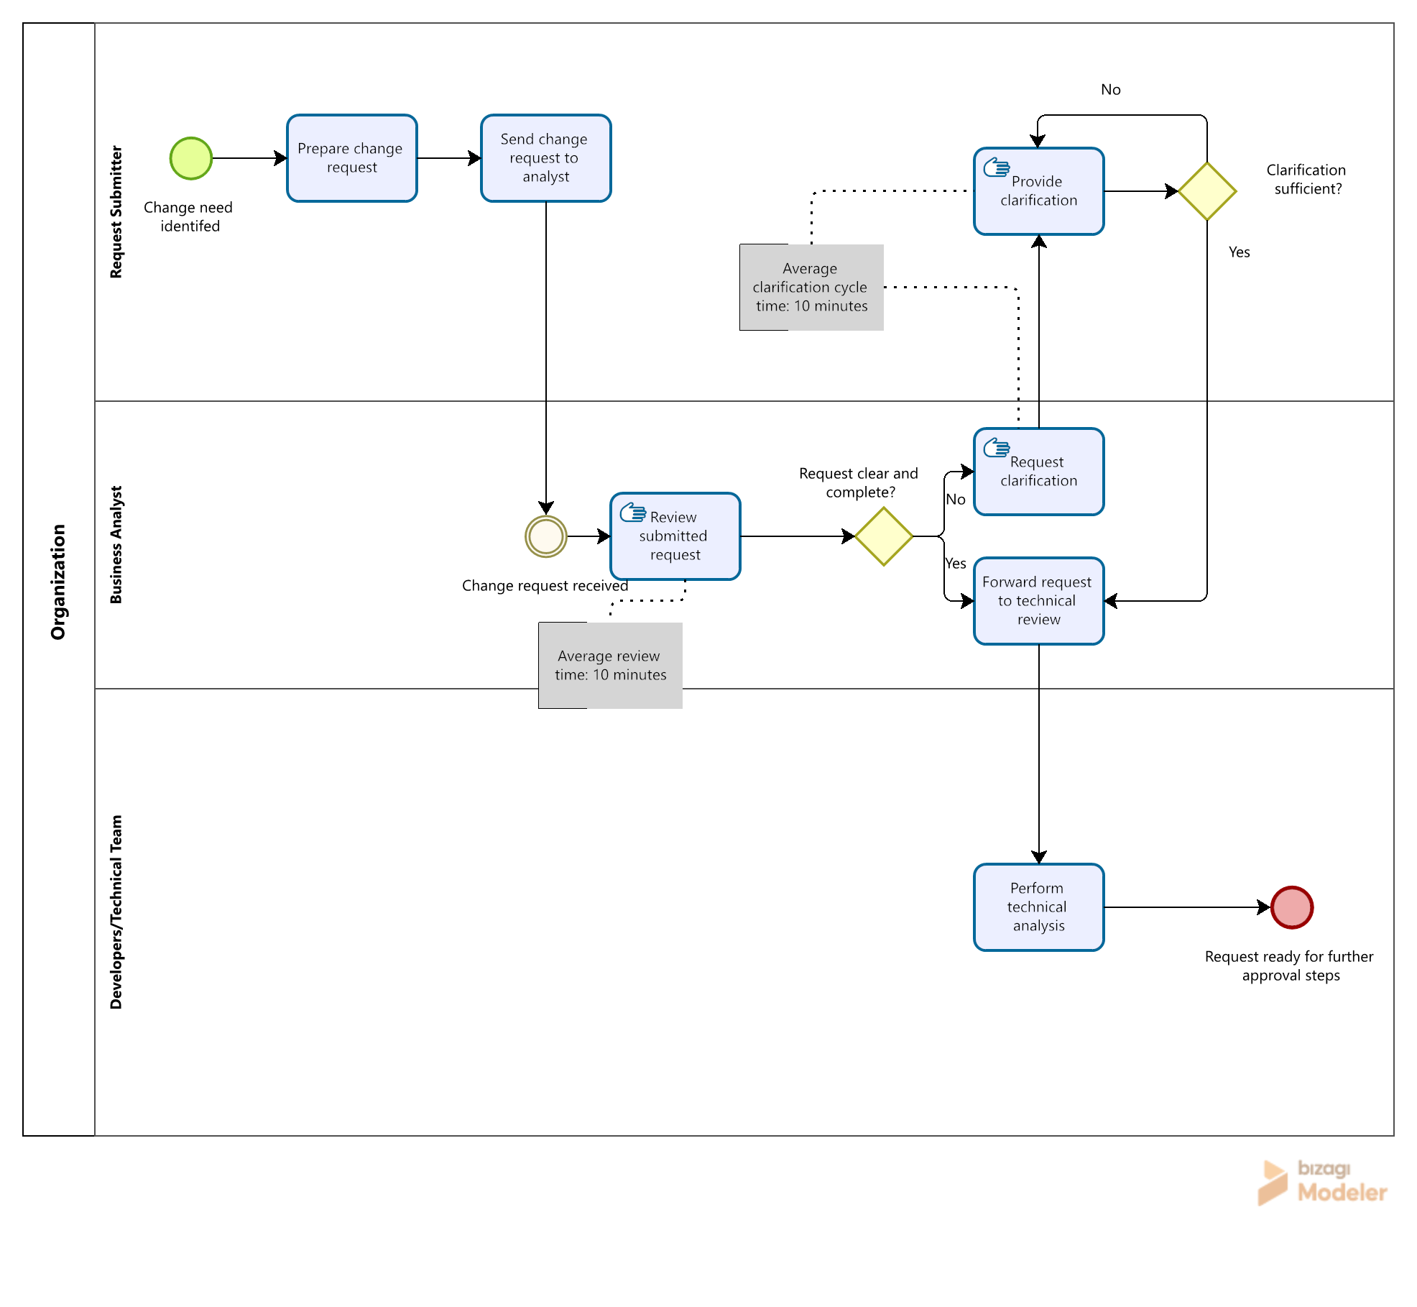

Current State Issues
The current process presents several limitations that reduce the effectiveness of early-stage change handling.
Key issues include:
- Request information is not consistently structured
- Important details may be unclear, incomplete, or buried within lengthy descriptions
- Records may be fragmented across departments, systems, or local documentation methods
- Business analysts must spend additional time interpreting and clarifying requests
- Communication between business and technical stakeholders may be inconsistent
- The intake process depends heavily on manual effort and repeated follow-up
Process impact
These issues lead to several operational consequences:
- Slower request intake and review
- Increased effort during early-stage analysis
- Reduced clarity regarding the true business need
- Inconsistent understanding of request scope and urgency
- Weaker foundation for later technical review and implementation planning
Overall, the current state creates avoidable inefficiencies at the point where change requests first enter the process.

Future State Overview
In the future state, change requests will be submitted through a centralized web-based Change Request Management Application. The system will provide a structured request form through which users can enter key request information, including the responsible department, request priority, and a detailed description of the change need. The system will also include an AI-assisted feature that helps organize the submitted description into a draft structured summary for review. Once reviewed and saved, the request will be routed to the responsible technical team for further assessment.
Users will continue to provide a free-text description of the requested change, issue, or enhancement. However, the system will include an AI-assisted feature that helps organize this content into a draft structured summary. This summary is intended to highlight the key elements of the request in a clearer format, while still allowing the user or analyst to review and refine the content before it is saved.
By introducing a centralized intake method and a more structured review process, the future state is intended to improve the clarity, consistency, and usability of submitted request information. This will support a more efficient transition from request submission to analysis and technical review.

Future State Process Steps
The future process may be summarized as follows:
- A user identifies a need for change.
- The user accesses the Change Request Management Application.
- The user completes a structured change request form.
- The user selects the relevant department or responsible area.
- The user selects the request priority.
- The user enters a detailed description of the change need.
- The system generates a draft structured summary using an AI-assisted feature.
- The business analyst reviews the generated summary and edits it where necessary.
- The system saves the request and reviewed summary in the centralized system.
- The system routes the request to the responsible technical team.
- The structured request becomes available for further technical analysis and assessment.
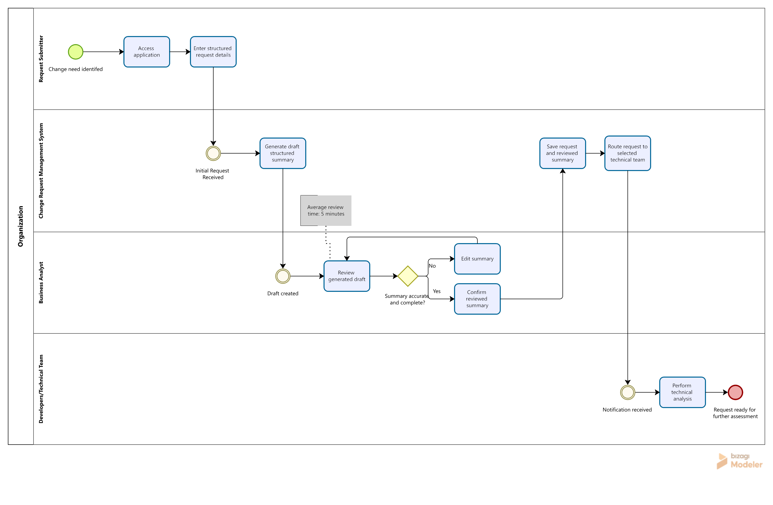

Future State Improvements
The future state is expected to improve the intake and early review of change requests in several important ways.
Expected improvements include:
- Requests are submitted through a single centralized system
- Request information is captured in a more consistent and organized manner
- Key request elements are easier to identify and review
- Manual interpretation effort is reduced during early-stage analysis
- Communication between stakeholders is improved through clearer request content
- Request records are stored in one location for easier access and follow-up
- Department ownership is identified earlier in the process
- Requests can be routed more efficiently to the responsible technical team
Operational effect
These improvements are expected to strengthen the overall intake process by creating a more structured starting point for downstream activities. Although the initial version of the system does not address the full change lifecycle, it provides a stronger foundation for future analysis, coordination, and process maturity.

Summary of Key Changes
Current State | Future State
Requests may be submitted through different channels and local methods | Requests are submitted through a centralized web application
Requests formats vary by user or department | Request information is captured in a more structured and consistent format
Analysts manually interpret long or unclear request descriptions | The system supports early review through an AI-assisted draft summary
Clarification may require repeated follow-up | Key requests elements are identified earlier in the process
Records may be distributed across systems, documents, or departments | Request information is stored centrally
Early-stage review depends heavily on manual effort | Early-stage review is supported by clearer and more organized request data
Department ownership may need to be interpreted manually | Department or responsible area is identified at submission
Requests may be passed manually between teams | Requests are routed to the responsible technical team through the system

